Publication immediately
Consecutive No, Short Title 07-2018, Leica Aibot announced
Leica Geosystems combines new UAV technology with DJI aerial platform to complete flight missions in less time

New Leica Aibot facilitates more accurate, safer aerial surveys

(Heerbrugg, Switzerland, 12 June 2018) - Leica Geosystems, part of Hexagon, industry leader in measurement technology, announced today the new Leica Aibot, the latest Unmanned Aerial Vehicle (UAV) system based on DJI’s aerial platform, the M600 Pro, to rapidly and autonomously acquire mobile 3D mapping data.

The new Leica Geosystems UAV technology allows users to get a complete data set in less time with a user-friendly and innovative interface, opening new business opportunities while spending less time, costs and effort than with traditional methods. Leica Geosystems software suite supports the new UAV workflows. Using Leica Infinity for point cloud, digital surface model and orthophoto generation enables surveyors to easily process and visualise aerial data to maximise productivity and speed-up data delivery. Supporting users to share data to Cylcone and Cloudworx, the integration of the UAV point cloud with terrestrial scan data enables users to make the most informed decisions. This complete set of data results in higher project efficiency.

“With constant new ideas, projects and numerous challenges it is crucial for our business to have access to transformational technologies such as the new Leica Aibot, that keep our projects on schedule with the maximum accuracy and precision,” said Martin Schwall, owner and managing director of IngenieurTeam GEO. “We look forward to continue using Leica Geosystems technology and adding Leica Aibot to our portfolio.”

Automating operations
The new UAV technology, developed in partnership with DJI, the world's leading manufacturer of UAVs allows users to process and analyse millions of data points gathered from above and visualise the data to provide actionable information. UAV data can be combined with existing survey technologies, such as TPS, GPS and laser scanning, providing a more complete set of information.

“We are very excited to offer our robust and reliable DJI M600 Pro along with our developer tools to Leica Geosystems to empower survey professionals to get a truly efficient solution workflow with the best results and accuracy,” said Jan Gasparic, Head of DJI Enterprise.

Throughout a project lifecycle of planning, designing and construction, Aibot provides easier access to critical information to perform volume calculations and monitor site progress. From creating digital terrain models to stripping and bulk earthworks and trenching to finally fine grading, paving and compaction, the solution supports easier actuals comparisons. This provides a more transparent view of site progression monitoring and volume calculations with safer operations to keep projects on schedule.

The Aibot can identify gaps early with a level of accuracy previously unknown for the construction industry. High definition imagery and 3D mapping allow for the viewing of site mapping or progress documentation, meaning users save time and money at all stages of the project.

"The Leica Aibot opens tremendous amounts of opportunity and helps the customers to speed up digitisation of processes and to automate existing workflows," says Valentin Fuchs, Leica Geosystems UAV product manager. "It enables customers to run businesses that are more efficient than their predecessors and be more profitable."

Further information about the Leica Aibot can be found at https://leica-geosystems.com/products/uav

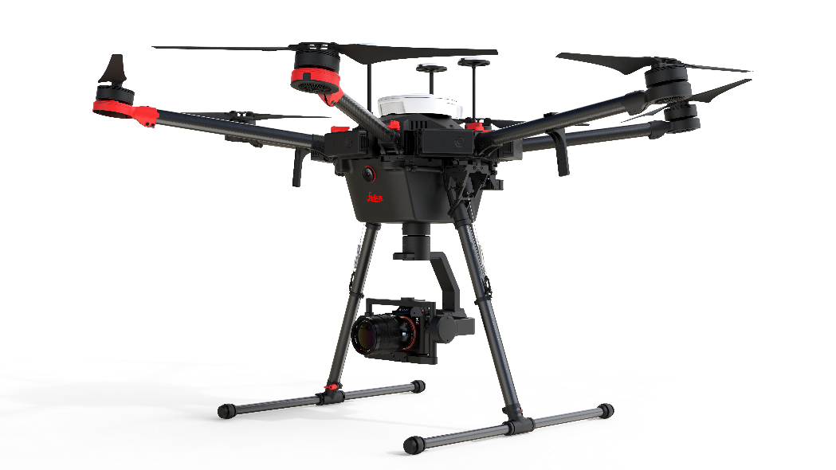

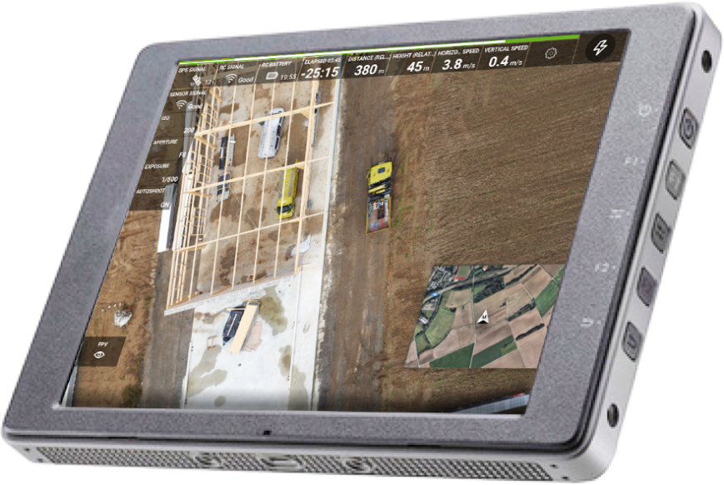

The new Leica Aibot UAV allows users to get a complete data set in less time
with a user-friendly and innovative interface.

Leica Geosystems – when it has to be right
Revolutionising the world of measurement and survey for nearly 200 years, Leica Geosystems, part of Hexagon, creates complete solutions for professionals across the planet. Known for premium products and innovative solution development, professionals in a diverse mix of industries, such as aerospace and defence, safety and security, construction, and manufacturing, trust Leica Geosystems for all their geospatial needs. With precise and accurate instruments, sophisticated software, and trusted services, Leica Geosystems delivers value every day to those shaping the future of our world.
Hexagon is a global leader in digital solutions that create Autonomous Connected Ecosystems (ACE). Hexagon (Nasdaq Stockholm: HEXA B) has approximately 18,000 employees in 50 countries and net sales of approximately 3.5bn EUR. Learn more at hexagon.com and follow us @HexagonAB.
About DJI
DJI, the world’s leader in civilian drones and aerial imaging technology, was founded and is run by people with a passion for remote-controlled helicopters and experts in flight-control technology and camera stabilization. The company is dedicated to making aerial photography and filmmaking equipment and platforms more accessible, reliable and easier to use for creators and innovators around the world. DJI’s global operations currently span across the Americas, Europe and Asia, and its revolutionary products and solutions have been chosen by customers in over 100 countries for applications in filmmaking, construction, inspection, emergency response, agriculture, conservation and other industries.

For more information about DJI’s enterprise solutions, visit https://enterprise.dji.com/.

For further information please contact:
Leica Geosystems AG
Penny Boviatsou
Phone: +41 41 727 8960
Fax: +41 (0)71/726-5511
penny.boviatsou@leica-geosystems.com
www.leica-geosystems.com

For additional information about DJI, please contact:
Olivier Mondon, Communication Manager – olivier.mondon@dji.com

